The Treatment of Microbubble Disease of 20th Century Cellulose Acetate Microfilm: Application of Ethyecellulose and Microrepair Method
Zhihui Jia*, Jing Li, Yuhu Li*, Yunpeng Qi, Daodao Hu, Huiping Xing, Xiaolian Chao
School of Materials Science and Engineering, Engineering Research Center of Historical Cultural Heritage Conservation, Ministry of Education, Shaanxi Normal University, Xi'an, Shaanxi, 710119, China

Submitted to Heritage Science

*Corresponding author:
Prof. Yuhu Li, E-mail address: liyuhu@snnu.edu.cn
Dr. Zhihui Jia, E-mail address: jzh1988@snnu.edu.cn

Abstract
The microbubble disease of cellulose acetate microfilm is accompanied by the production of acetic acid syndrome, which has a negative influence on the integrity of image information. In the present study, cellulose acetate microfilm produced microbubble disease from the Republic of China (AD 1912-1949) collected in the Second Historical Archives of China is chosen as a prototype to study its treatment methods. A combination of optical microscopic and needle is carried out to remove plasticizer in microbubble for the first time. The plasticizer can be effectively removed by infiltrating n-butanol into the microbubble from a small hole broken by the needle. Owing to the unclear image information after plasticizer removed, the SEM and laser confocal microscope are used to study the morphology and roughness of the inner surface of microbubble. It can be found that the unclear image information is attributed to the light scattering from rough interface. Based on the advantages of ethyl cellulose in file protection, the optimal concentration of ethyl cellulose is selected and used to fill the interior of the microbubble to obtain clearer image information. To determine the protective potential of this filling materials, the chemical and mechanical properties of coated film after dry heat, hygrothermal and UV accelerated aging are measured. Based on the above-mentioned results, it is encouraging that a new microrepair method and its corresponding method are offered in film treatment work.

Keywords: Cellulose acetate film, Microbubble, Microrepair technique, Ethyl cellulose

Introduction
Cellulose acetate (CA) as a versatile material has obtained special attention at the beginning of the 20th century due to its safety alternative to the highly ﬂammable cellulose nitrate in textiles, food, tool handles, and so on [1-3]. It deserves mentioning that its most signiﬁcant application is as a base for photographic ﬁlm [4-5]. Affected by the properties of materials made and the preservation environment, the stability of cellulose acetate film is suffering from hydrolysis of the ester side chain [6-7]. This process accompanies with the release of acetic acid, and its concentration increasing in the tightly sealed cases, which make the hydrolysis reaction becoming autocatalysis [8-10]. Another deterioration mechanism is the migration of plasticizer, the presence of white crystals on the surface of the substrate is observed when the plasticizer moves towards the substrate [11-14]. While the white spots also called as microbubble disease are observed when the plasticizer moves towards the image layer.
Recently, we have studied the causes of microbubble diseases of microfilm collected in the Second Historical Archives of China [9]. The results showed that microbubble disease is accompanied by the production of the vinegar syndrome of cellulose acetate film. Microbubbles are mainly produced between the protective layer and the emulsion layer with different shapes and sizes. The structure is closed and the diameter is 0.1-2 mm. The crystals inside the microbubbles are plasticizer, which significantly affects the integrity of the image information. Therefore, it is essential to develop a new repair method to reduce the negative effects of microbubble disease on the image information.
Conservation based on the physics and chemical strategies is expected to be a solution for the protection of cellulose acetate film. The film protection guidelines which provide the most basic theoretical knowledge of film protection are developed [16-17]. In addition, digital restoration technology favored by film collectors is a safe and reliable repair method [18-20]. However, the image information and lifetime of film will not be effectively protected if itself disease is not be valid treated using digital restoration. In terms of this issue, our group has performed the protection research of vinegar syndrome of cellulose acetate film in the recent years [21-23], and found that the crystals on the surface of cellulose acetate film can be effectively removed [24]. However, removal of plasticizer in closed structure of microbubble disease is poorly understood to date. Therefore, we believe that a combination of optical microscopic and needle is an effective method to repair these special diseased films.
As a semi-crystalline cellulose polymer derivative, ethyl cellulose (EC) has the characteristics of odorless, non-toxic and physiological inertia. EC is currently used in a variety of industrial applications benefit by generally regarded as safe (GRAS) status [25]. Commercial version of EC has good solubility and superior performance, such as mechanical strength, light resistance, durability, excellent elasticity over a wide temperature range [26-28].
The object of this study is to explore an effective method for repairing the microbubbles disease to better protect cellulose acetate film. Samples of cellulose acetate film with microbubbles disease from the Republic of China (AD 1912-1949) collected in the Second Historical Archives of China. Considering the small size and closed nature of microbubbles that cannot be repaired by conventional methods. Optical microscopic technique combined with the needle is applied to remove plasticizer from microbubbles for the first time. The scanning electron microscope (SEM) and laser confocal microscopic are used to study the morphology and roughness of the inner surface of microbubble. In order to obtain a clearer image, EC is taken into consideration as filling materials due to its functions of adhesion, filling, film formation. To determine the protective potential of this filling materials, the tensile strength, folding endurance and optical density of coated film after dry heat, hygrothermal and UV accelerated aging are measured.

Experimental
Sample description
Cellulose acetate microfilms of the Republic of China (1946s) collected in the Second Historical Archives of China were selected in this study. These microfilms recorded China's diplomacy during the republic of China and were very valuable cultural relics. Part of the microfilms without disease (Fig. 1a), while the other parts were found produced white spots (microbubbles disease) (Fig. 1b). In the present study, one roll of microfilms with microbubbles was investigated.
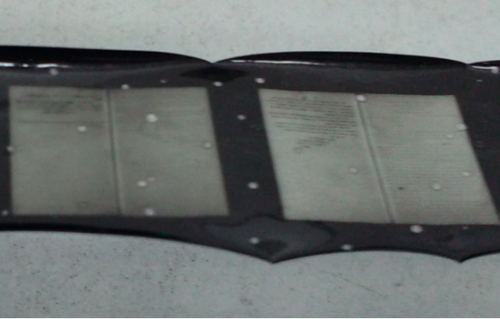
b
a
Fig. 1 Cellulose acetate microfilm of the 1946s collected in the Second Historical Archives of China: (a) The sample without microbubbles disease; (b) The sample with microbubbles disease

Materials
All the reagents were of analytical grade from Aladdin (China) and used as received. Ethyl cellulose (EC) with molecular weight of 100,000 was used as filling material. n-butyl alcohol was selected as solvent. Stainless steel needles also be called acupuncture needle (0.18 × 25 mm) are bought at a drugstore.

Cleaning plasticizers in microbubbles
In order to obtain the integrity image information, it is essential to remove the crystals inside the microbubble. The film was placed in the optical microscope (XWY-VI Fiber analyzer) with the image layer facing up. The detailed process of cleaning plasticizers in microbubbles was organized as follows (Fig. 2): (1) the position of microbubble was fixed in the center of the microscope's field of view; (2) n-butyl alcohol which was usually applied a cleaner for plasticizers [19] dipped with a cotton swab and wiped the surface; (3) the stainless steel needle was used to puncture the protective coating of microbubble with proper force, followed by plasticizer inside the bubble was cleaned by repeatedly dipping and pressing; (4) the cleaning agent was adsorbed along the microbubble edge using filter paper and dried in natural conditions.
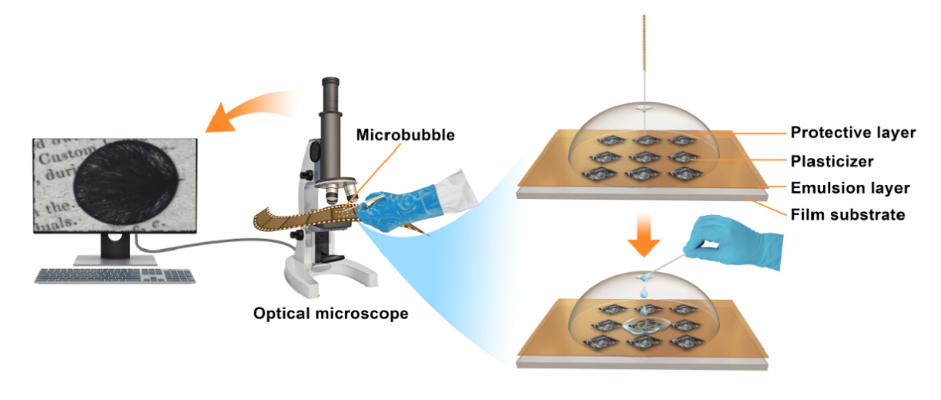
Fig. 2 The process of cleaning plasticizers in microbubbles
Conservation procedure and characterization methods
Two pieces of film with microbubbles (~ 5 × 5 mm²) which contain no image information were chosen at the edge of film. One of pieces of film was penetrate into filler material and other is not. The protective layer of microbubbles was removed and the surface morphology of the internal interface was tested by the scanning electron microscope (SEM observation). It was placed image layer up on sticky tapes on aluminum SEM specimen holders. Several coupons were examined using a Hitachi SU3500 SEM. Analyses were performed at low vacuum (1-150 Pa), with an accelerating voltage of 5 kV. Magnification was 40 ×. Image layer were placed up on two-sided sticky tapes on aluminum laser confocal microscope (Keyence VK-X250K) specimen holders. The 3D morphology of the sample surface was analyzed through a 20× optical lens. The surface roughness parameters of the sample were obtained by using the software VK-H1XMC, such as S_{a}, S_{z}, S_{tr}, S_{pc}, S_{dr}.
Screening of filling materials: the concentration of EC was screened as filling material. By adding EC to a round bottom three-mouth flask containing n-butanol and heating reflux, n-butanol solutions with different concentrations of EC can be obtained. Different concentrations of EC solutions were permeated into the microbubbles according to the method in 2.3, and the best concentration of the repair solution was screened by taking the permeation effect and the clarity of image information as parameters.
In order to study durability of filling materials, the control specimens (Cellulose acetate film is collected in China Film Archive.) were prepared as follows. Image layer of film was removed by sodium hypochlorite solution, the filling material was evenly coated on the surface of the substrate, then drying at room temperature, 5% gelatin aqueous solution was coated on the surface of the filling agent to dry naturally. Comparative study with samples of uncoated filling material. The mechanical properties of the specimens were performed on an computer testing and control universal material tester fitted with a 50 N load cell for tensile testing, equipped with pneumatic grips with 25 mm gauge length, operating at a cross head speed of 250 mm/min, alongside with long axis in the film transverse direction. Film samples were cut into 22 × 200 mm strips following ASTM D882 test method. Reported values were calculated as average ± 1 standard deviation by testing at least 20 samples. Folding endurance tests on specimens were performed using a Schopper type folding endurance tester and the applied force was 7.5 N according to GB/T 9858-1988. Reported values were calculated as average ± 1 standard deviation by testing at least 20 samples. The film optical density was tested using a table type transmission density meter. Reported values were calculated as average ± 1 standard deviation by testing at least 20 samples.
The artificial accelerated aging tests were performed employing the BH0-402A aging chamber at 105 ºC for 21 days. The hygrothermal accelerated aging of the specimens were placed at 40 ºC, 60% relative humidity (RH) for 21 days. The UV accelerated aging of the specimens was performed in a self-made UV aging box with a lamp (365 nm, 30 W) at 50% RH and 25 ºC for 21 days. Then the specimens were balanced at 50% RH and 25 ºC for 24 h before testing. In the actual measurement process, each experimental value is the arithmetic mean of at least ten measurements with standard deviation less than 5%.
The reflectance spectra were recorded in the range of 400-700 nm using a multi-angle spectrophotometer (MA98, X-Rite, USA) with the colorimetric illuminant of D65. In actual measurement, each of these experiments was repeated at least three times, and representative results are given. Standard deviations were below 5%, and this deviation would not aﬀect our conclusion.

Results and discussion
Cleaning of plasticizers in microbubble
Fig. 3 depicts the photos of microbubble of cellulose acetate film before and after plasticizer cleaned and its corresponding SEM image. It can be seen from Fig. 3a and 3b that the plasticizer is cleaned using the combination of optical microscopic and steel needle, and the covered original handwriting is revealed. Although the plasticizer is cleaned in some microbubbles, the image information is not enough clear. The SEM is used to observe the morphology of microbubble inner surface with the removing of protective layer (Fig. 3c). It can be found that the inner surface of microbubble is rough due to the formation of microbubbles.
a
c
b
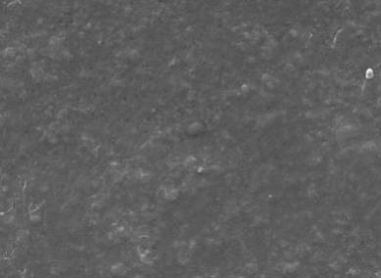
1.0 mm
1.0 mm
200 μm
Fig. 3 (a) Photos of microbubble before plasticizer cleaned; (b) Photos of microbubble after plasticizer cleaned; (c) SEM image of the inner surface of microbubble after remove the protects of gelatin
Previous literature has confirmed that the shortening of incident light pathway is the fundamental influence factor leading to the blurred image [29]. From Fig. 3b, it is seen that some small spots emerge inside the microbubble. The light scattering is increased when the light passes through the bottom of film. This is because the uneven interface exists in the microbubble. Therefore, the filling materials are selected to permeate inside the microbubble and to weaken the scattering of rough interface.
Conservation applications of EC
Through the selection of polymer materials commonly used in the field of cultural relic protection, the ethyl cellulose is chosen to employ as the main polymer filling material. The n-butanol is used as the solvent. As shown in Table 1, 3% n-butanol solution of EC has the shortest permeation time. The permeation time of 5% n-butanol solution of EC is larger than the 3% n-butanol solution. 7% and 10% n-butanol solution of EC take longer time and harder penetrate compared to 3% and 5% n-butanol solution. Fig. 4 shows the photos of penetrate effect using different concentration of n-butanol solution of EC. The clarity of image information is increased with the concentration of EC ranging from 3% to 5% (Fig. 4b-c), whereas it is decreased with the concentration of EC more than 5% due to the increase of viscosity and the decrease of permeability (Fig. 4d-e). Based on above results in the present study, 5% n-butanol solution of EC is selected as the filling material.
Table 1 The concentration screening of filling material
 | concentration
EC | w. 3% | w. 5% | w. 7% | w. 10%
Permeation time(s) | < 30 | 30-50 | >60 | >100
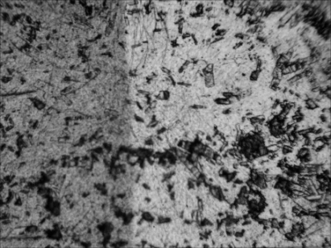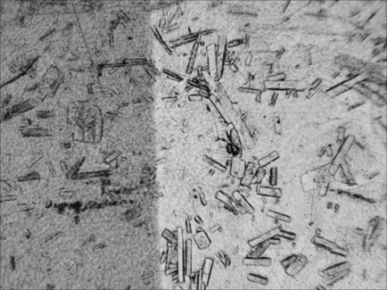
a
c
d
e
b
0.5 mm
0.5 mm
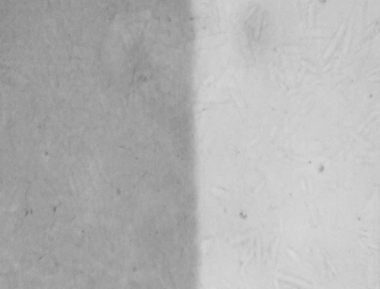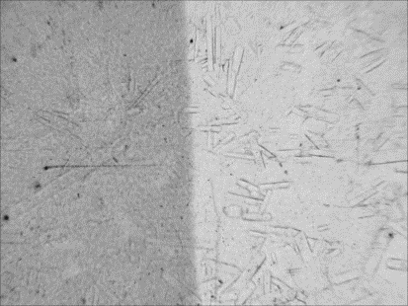
0.5 mm
0.5 mm
0.5 mm
Fig. 4 (a) photo of the unfilled rough interface; (b) photos of the filled interface with 3% EC; (c) photos of the filled interface with 5% EC; (d) photos of the filled interface with 7% EC; (e) photos of the filled interface with 10% EC
Accelerated ageing tests can be used to study the long-term behavior of a variety of filling materials. Hydrolysis and oxidation are the main pathway for the degradation of filling materials [30-34]. Therefore, temperature, humidity and ultraviolet as the main parameters are chosen to investigate the durability of filling material (Fig. 5). The folding endurance and tensile strength are selected as the important indicators to character the mechanical properties of film. The effects of dry heat, UV and hydrothermal aged on the tensile strength and folding endurance of samples before and after treatment are shown in Fig. 5a and 5b. It can be seen that the tensile strength and folding endurance of treated samples increase slightly. Compared with the treated samples, the tensile strength and folding endurance of untreated samples are decreased significantly after aged. The effect of hydrothermal aged on film is greater than that of dry heat and ultraviolet aged, implying that relative humidity and temperature are the main factors influencing the process of film aged. The treated samples have higher damp, hot and UV stability and exhibit smaller loss of film strength compared to untreated samples. From Fig. 5c, it can be seen that the optical density is not changed before and after coating filling materials on the base surface. The transmittance of the untreated samples is decreased more than that of the treated sample with the increase of the aged times. The result indicates that the filling materials have the good durability.
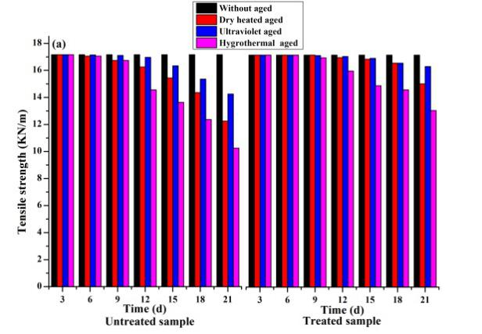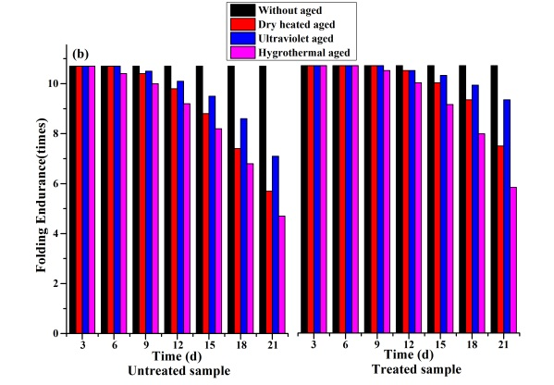
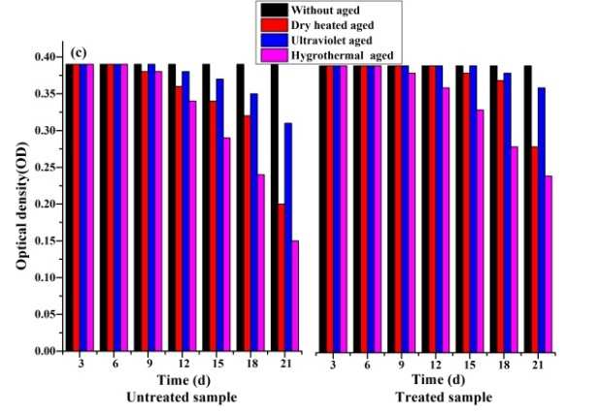
Fig. 5 (a) Tensile strength; (b) Folding endurance; (c) Optical density
According to the process of cleaning plasticizers in microbubbles mentioned in experimental section 2.3, a certain amount of filling materials is infiltrated into the interior of the cleaned microbubble to obtain more clarity image information. Compared with the image information of microbubble after cleaned (Fig. 6b), the image information becomes more clearly (Fig. 6a) and the interface becomes uniform and flat (Fig. 6b). The main reason may be that the filling materials forms EC films that adhere to the rough surface inside the microbubble. On the other hand, the difference of the refractive index of rough interfacial particles and filling materials decrease leading to the decrease of light scattering, enhancing the clarity and visibility of image [29].
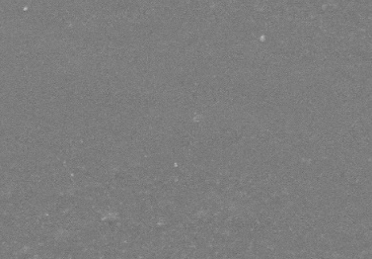
b
a
200 µm
1.0 mm
Fig. 6 Photos of the repair effect of filling materials as view in optical microscope (a) the photo of microbubble after filled; (b) SEM image of the inner surface of microbubble after filled
The keenes VK-X250K shape analysis and laser confocal microscope are used to character the internal surface morphology and roughness of microbubbles before and after filled the filling materials. Surface geometric features are described by morphology parameters. The most commonly used parameter is surface roughness, which is represented by the contour curve of a section on the surface [35]. The surface roughness is smaller indicating the surface is smoother. As shown in Fig. 7, the internal interface of microbubble is fluctuated significantly after cleaned with the height of 18.51-45.52 µm, while it is relatively uniform and smooth after filled with the height of -2.46-8.13 µm. The sample surface roughness parameters are obtained using keenes file analysis software vk-h1xmc after corrected, and the measured area is ~ 268 × 358 µm (Table 2). The measured mean surface arithmetical height (S_{a}) of the inner interface of microbubble after cleaned is 0.971 µm. The S_{a} of the inner interface of microbubble after filled with filling materials is 0.367 µm. The maximum height (S_{z}) at the inner interface of microbubble is 27.014 µm after cleaned, while it drops to 10.589 µm after filled. The ratio of height to width of surface properties (S_{tr}) of the microbubble interface is 0.612, whereas it decreases to 0.172 after filled. The S_{tr} is closer to 1 indicating the surface uniformity is more poor and surface peaks ups or downs has no direction. The experimental result is further confirmed that the internal interface of microbubble is not uniform. The arithmetic mean peak curvature (S_{pc}) of the inner interface of microbubble is 4167.165 mm⁻¹ after cleaned, whereas it reduces to 1299.603 mm⁻¹ after filled, indicating that the sharpness of surface peaks is reduced. The area ratio of interface expansion (S_{dr}) of microbubble interface is 0.455 after cleaned, whereas it decreases to 0.076 after filled. Based on the above discussion, it can be found that the inner interface of the cleaned microbubble become more uniform and smooth.
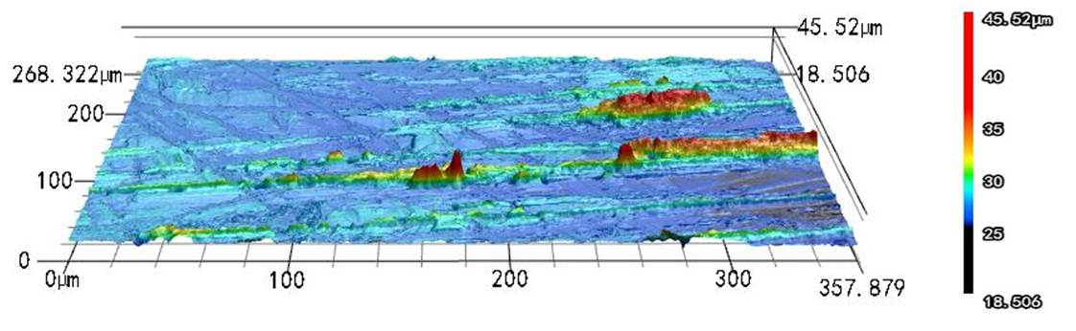
b
a
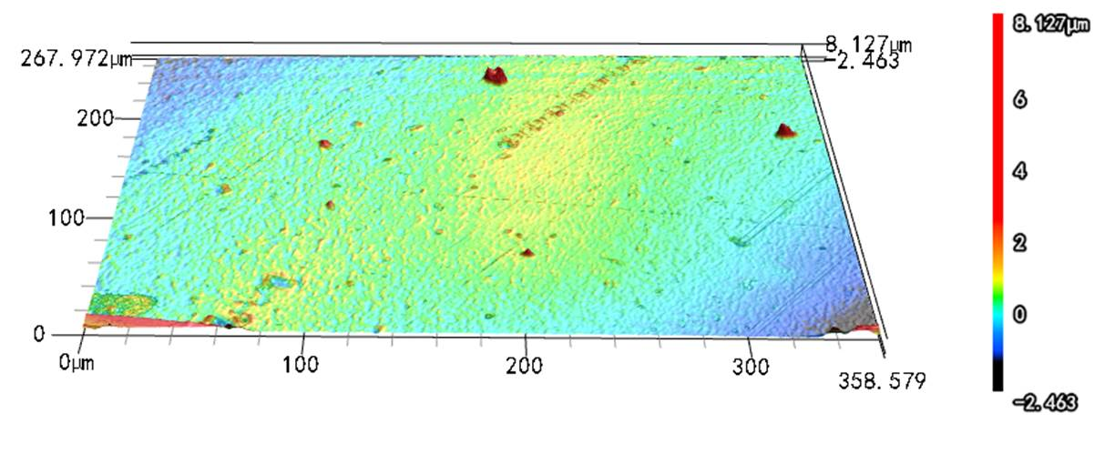
Fig. 7 3D morphology of microbubble after cleaned (a) and after filled (b)
Table 2 Surface roughness test results of film
 | S_{a} (µm) | S_{z} (µm) | S_{tr} (1/mm) | S_{pc} | S_{dr}
a | 0.971 | 27.014 | 0.612 | 4167.165 | 0.455
b | 0.367 | 10.589 | 0.172 | 1299.603 | 0.076

The light scattering characteristics of rough surface inside in the microbubble are directly related to the reflectivity, which is determined by surface reflectivity spectrum at the visible light range [36]. And the measured result is shown in Fig. 8. The reflectivity of the internal surface of microbubble after cleaned is greater than that of the filled surface. Though the combination of Fig. 7 and 8, it can be found that the internal surface of microbubble is very rough after cleaned, leading to the diffuse reflection of visible light enhanced.

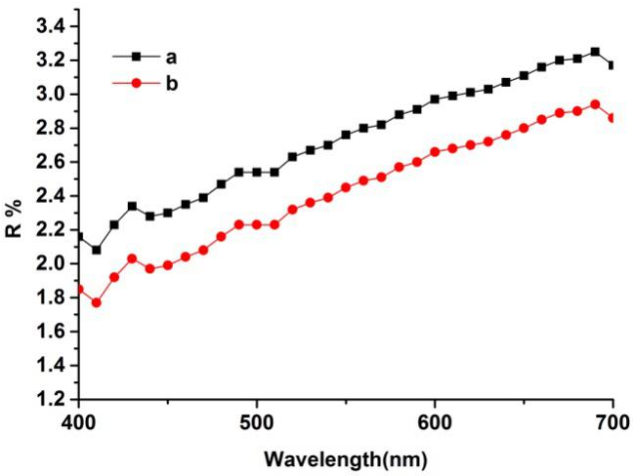
Fig. 8 Visible light reflectance of the inner surface of the microbubble after cleaned (a) and after filled (b)
On the basis of above analysis, we propose the mechanism of action about filling materials and the corresponding schematic illustration is drawn in Fig. 9. The image presentation derived from optical microscope mainly depends on the transmission of light. The diameter of microbubble is 0.5-2 mm and it is filled with plasticizer crystals. Visible light is majorly reflected in the microbubble due to its wavelength much larger than the visible light. Therefore, we observe the black dot with a diameter of 0.5-2 mm on the screen. The surface is rough after the plasticizer inside in the microbubble cleaned, leading to the increase of diffuse reflection and resulting in blurred images. This phenomenon can be illustrated by the theory of light scattering that the dots formed from the rough surface have some scattering effects on the incident light [37]. Moreover, the scattering layer shorten the pathway of incident light and weakens the transmitted light of image, resulting in unclear image and black spots [38-39]. The refractive index difference between the space and filling material is decreased when the filling materials with a higher refractive index is filled into the microbubble. Followed by the light scattering is decreased significantly, leading to the received transmitted light increases.
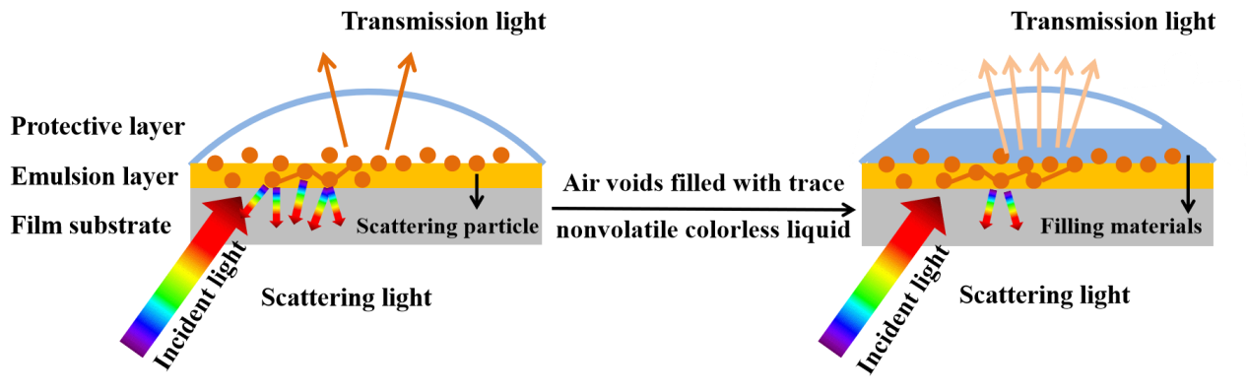
Fig. 9 Schematic illustration of the mechanism of action about filling materials

Conclusion
In summary, the repair method of microbubble disease is investigated using silver needle by optical microscopic for the first time. It is successfully used to infiltrate n-butanol into the microbubble and effectively remove the crystals during repeated pressing. The morphology and roughness of the microbubble surface are characteristic by using SEM and laser confocal and found that the phenomenon of unclear image information may be caused by light scattering from rough surface interface. 5% of n-butanol solution of EC is used to fill the interior of microbubble to obtain a clearer image information. The aging resistance of filling materials is evaluated using dry heat, hygrothermal and UV accelerated aging method. The degradation of mechanical properties of film after artificial aging was measured by tensile strength, folding endurance tests and optical density, and find that filling materials have the good durability. Furthermore, the possible mechanism on the process of filling materials are infiltrated into the interior of the cleaned microbubble is proposed. After a comparative study on the roughness and reflectivity of the inner interface of the microbubble before and after the filling, we believe that the light scattering phenomenon of the rough interface inside the microbubble is the main reason for the unclear image. The high refractive index of the filling liquid reduces the light scattering phenomenon to obtain a clear image information.

Abbreviations
SEM, scanning electron microscope; TG, thermal gravimetric; XRD, X-ray diffraction; FT-IR, Fourier transform infrared; EC, Ethyl cellulose;

Availability of data and material
The data sets analyzed during the current study are available from the corresponding author on reasonable request.

Competing interests
The authors declare that they have no conﬂict of interest.

Funding
The research is financially supported by Fundamental Research Funds for the Central Universities (Grant Nos. GK 201903049 and 201903054) and National Natural Science Foundation of China (Grant No. 51403121)

Author contributions
YQ, YZ, and JL performed the measurements and contributed to the SEM, XRD, TG, NMR and FT-IR Data analysis; HX wrote most of the initial versions of the text and figures. All authors contributed to research strategy, the discussion and interpretation of the results and to the final form of the text and figures. All authors read and approved the final manuscript.

Acknowledgments
This work was supported by the Fundamental Research Funds for the Central Universities (Grant Nos. GK 201903049 and 201903054) and National Natural Science Foundation of China (Grant No. 51403121).

References
- D. W. Grattan. Saving the twentieth century: the conservation of modern materials, In: Proceedings of a conference symposium’91: saving the twentieth century, Ottawa, Canada, 15-20 September, 1991.
- Y. Shashoua. Inhibiting the inevitable: current approaches to slowing the deterioration of plastics, Macromolecular Symposia. 2006; 238: 67-77.
- J. Mazurek, A. Laganà, V. Dion, S. Etyemez, C. Carta, M. R. Schilling. Investigation of cellulose nitrate and cellulose acetate plastics in museum collections using ion chromatography and size exclusion chromatography, Journal of Cultural Heritage. 2019; 35: 263-270.
- P. Z. Adelstein, J. M. Reilly, D. W. Nishimura, C. J. Erbland, J. L. Bigourdan. Stability of cellulose ester substrate photographic film: part V: recent findings, SMPTE J. 1995; 104: 439-447.
- M. Schilling, M. Bouchard, H. Khanjian, T. Learner, A. Phenix, R. Rivenc. Application of chemical and thermal analysis methods for studying cellulose ester plastics, Accounts of Chemical Research. 2010; 43: 888-896.
- Y. Shashoua. Conservation of plastics: materials science, degradation and preservation, Journal of the American Institute for Conservation. 2010; 49: 55-57.
[7] J. Tsang, O. Madden, M. Coughlin, A. Maiorana, J. Watson, N. C. Little, R. J. Speakman. Degradation of ‘lumarith’ cellulose acetate: Examination and chemical analysis of a salesman’s sample kit, Studies in Conservation. 2009; 2: 90-105.
[8] D. Littlejohn, R. A. Pethrick, A. Quye, J. M. Ballany. Investigation of the degradation of cellulose acetate museum artefacts, Polymer Degradation and Stability. 2013; 98: 416-424.
[9] K. Sutherland, C. Schwarzinger, B. A. Price. The application of pyrolysis gas chromatography mass spectrometry for the identification of degraded early plastics in a sculpture by naum gabo, Journal of Analytical and Applied Pyrolysis. 2011; 94: 202-208.
[10] A. Quye, D. Littlejohn, R. A. Pethrick, R. A. Stewart. Investigation of inherent degradation in cellulose nitrate museum artefacts, Polymer Stability and Degradation. 2011; 96: 369-376.
[11] J. E. Ayuk, A. P. Mathew, K. Oksman. The effect of plasticizer and cellulose nanowhisker content on the dispersion and properties of cellulose acetate butyrate nanocomposites, Journal of Applied Polymer Science. 2009; 114: 2723-2730.
[12] E. Richardson, M. T. Giachet, M. Schilling, T. Learner. Assessing the physical stability of archival cellulose acetate films by monitoring plasticizer loss, Polymer Degradation and Stability. 2014; 107: 231-236.
[13] R. Quintana, O. Persenaire, Y. Lemmouchi, J. Sampson, S. Martin, L. Bonnaud, P. Dubois. Enhancement of cellulose acetate degradation under accelerated weathering by plasticization with eco-friendly plasticizers, Polymer Degradation and Stability. 2013; 98: 1556-1562.
[14] Ballany, J. Littlejohn, D. Pethrick, R. A. Quye. Probing the factors that control degradation in museum collections of cellulose acetate artefacts, Acs Symposium. 2000; 779: 145-165.
[15] Z. H. Jia, Y. H. Li, Y. P. Qi, Y. J. Zhou, D. D. Hu, X. L. Chao, H. P. Xing, J. Li. Study on microbubble of cellulose acetate microfilm of the Republic of China (AD 1912-1949) collected in the Second Historical Archives of China, Heritage Science. 2020; 8: 29-38.
[16] National film preservation foundation contributors. The film preservation guide: The basics for archives, libraries, and museums [M]. San francisco: National Film Preservation Foundation, 2004.
[17] A. Melville, S. Simmon. Film preservation 1993: A study of the current state of American Film Preservation[M]. New York: Library of congress, 1993.
[18] S. I. Sadhar, A. N. Rajagopalan. Restoration of scanned photographic images, Signal Processing. 2006; 5: 1035-1048.
[19] Y. Takahiro, F. Tatsuya, N. Mitsuru, S. Daisuke, S. Kazuhiro, F. Tetsuro. Superhigh-definition digital cinema distribution system with 8-Million-Pixel resolution, Systems and Computers in Japan. 2006, 4: 35-44.
[20] A. Kokaram. Detection and removal of line dcratches in degraded motion picture sequences, Signal Processing. 1996; 1: 5-8.
[21] Y. P. Qi, Y. J. Zhou, J. Zhang, Y. J. Huo, S. K. Shen, Y. H. Li. Research on the influence of acetic acid syndrome on the property of film substrate, Journal of Shaanxi Normal University (Natural Science Edition). 2017; 2: 63-67. (in Chinese)
[22] Y. J. Zhou, Y. H. Li, Y. He, X. L. Qin, C. X. Zuo. Discussion on storage conditions of cellulose acetate cine-film, Archives Science Study. 2010; 4: 66-69. (in Chinese)
[23] Z. H. Jia, Y. H. Li, M. R. Shi, L. N. Xie, Y. J. Zhou. The effect of temperature and humidity on the physical properties of cellulose acetate film, Imaging Science and Photochemistry. 2017; 6: 797-807.
[24] Y. J. Zhou, J. Zhang, Y. P. Qi, Y. H. Li, Y. He. Analyze and characterize the crystal precipitation from the acetic acid syndrome cine-film, Image Technology. 2015; 5: 60-64. (in Chinese)
[25] J. M. Aiache, P. Gauthier, S. Aiache. New gelification method for vegetable oils I: cosmetic application, International Journal of Cosmetic Science. 1992; 5: 228-234.
[26] G. S. Rekhi, S. S. Jambhekar. Ethylcellulose a polymer review, Drug Dev Ind Pharm. 1995; 1: 61-77.
[27] N. E. Hughes, A. G. Marangoni, A. J. Wright. Potential food applications of edible oil organogels, Trends in Food Science & Technology. 2009; 10: 470-480.
[28] A. K. Zetzl, A. G. Marangoni, S. Barbut. Mechanical properties of ethylcellulose oleogels and their potential for saturated fat reduction in frankfurters, Food Funct. 2012; 3: 327-337.
[29] L. Z. Zheng, X. T. Liang, S. R. Li, Y. H. Li, D. D. Hu. Fading and showing mechanisms of ancient color relics based on light scattering induced by particles, RSC Advances. 2018; 8: 1124-1131.
[30] E. Gauthier, B. Laycock, F. M. Cuoq, P. J. Halley, K. A. George. Correlation between chain microstructural changes and embrittlement of LLDPE-based films during photo- and thermo-oxidative degradation, Polymer Degradation and Stability. 2013; 98: 425-435.
[31] J. Kolar, M. Strlic, S. Pentzien, W. Kautek. Near-UV, visible and IR pulsed laser light interaction with cellulose, Applied Physics. A, Materials ence & Processing. 2000; 71: 87-90.
[32] V. Bukovsky, M. Trnková. The inflfluence of secondary chromophores on the light induced oxidation of paper part II: the inflfluence of light on groundwood paper, Restaurator. 2003; 24: 118-132.
[33] N. S. Hon. Formation of free radicals in photoirradiated cellulose. I. Effect of wavelength, Journal of Polymer Science Polymer Chemistry Edition. 1975; 13: 1347-1361.
[34] G. O. Phillips, O. Hinojosa, J. C. Arthur, T. Mares. Photochemical initiation of free radicals in cotton cellulose, Textile Research Journal. 1966; 36: 822-827.
[35] K. Klauer, M. Eifler, J. Seewig, B. Kirsch, J. C. Aurich. Application of function-oriented roughness parameters using confocal microscopy, Engineering Science & Technology. 2018; 3: 302-313.
[36] F. L. S. Cuppo, A. Garcı´a-Valenzuela, J. A. Olivares. Influence of surface roughness on the diffuse to near-normal viewing reflectance factor of coatings and its consequences on color measurements, Color Research & Application. 2013; 3: 177-187.
[37] M. Osterhold. Influence of substrate structure on coating appearance and the relevant characterization methods, Materialwissenschaft Und Werkstofftechnik. 1998; 29: 131-136.
[38] L. Simonot, M. Elias. Color change due to surface state modification, Color Research and Application. 2003; 28: 45-49.

[39] K. E. Torrance, E. M. Sparrow. Theory for off-specular reflection from roughened surfaces, Journal of the Optical Society of America B. 1967; 57: 1105-1114.

