Comparison of gray values of cone-beam computed tomography with Hounsfield units of multislice computed tomography using a U-Net based network
Wang Jingboª, Tao Xiaofengª, Zhao Liang^{b}, Yuan Jing^{b}, Liu Chang^{b}, Xie Shuaining^{b}, Dou Xin^{c,*}, Zhu Ling^{a,*}
ªShanghai Ninth Hospital, Shanghai Jiaotong University School of Medicine, China
^{b}SenseTime Research, Shanghai, China.
^{c}Sensebrain Technology, Princeton, USA.
* Dou Xin and Zhu Ling are co-corresponding author.
Dou Xin
Address:103 Carnegie Ctr Princeton, NJ 08540, USA.
E-mail address: xindou@sensebrain.site
Zhu Ling
Address: 639 Zhizaoju Road, Shanghai 200011, China.
E-mail address: zhuling1425@163.com

Abstract
Background：Dental departments generally employ cone-beam computed tomography (CBCT) instead of conventional computed tomography (CT), due to its lower price, smaller dosage, and high spatial resolution. During the corona virus disease 2019 (COVID-19) outbreak, CBCT is highly recommended to replace intraoral radiography because it greatly reduces the risk of exposure to salivary droplets. However, CBCT's inability to quantitatively measure tissue attenuation limits its application in differential diagnosis.
Methods: We employed a U-Net based network to generate synthetic CT from dental CBCT. The deep neural network can be trained end-to-end to learn the complex mapping between CBCT and CT values. By the U-Net architecture, low-level and high-level features are both utilized to get fine detailed synthetic CT. We applied our method on the collected dataset contains 62 patients.
Results: Experimental results on four metrics -- mean absolute error (MAE), root-mean-square error (RMSE), structural similarity index (SSIM), and peak-signal-to-noise ratio (PSNR) -- showed significant improvement of the synthetic CT compared to the original CBCT data. The MAE and RMSE improvement percentages are 64.44% and 66.44%. The MAE level of synthetic CT for most of the tissues are small enough to separate most important tissues, including dentin and cancellous bone, dentin and root canal，implants and cortical bone.
Conclusions: CBCT and synthetic CT values can be used to distinguish different high-attenuation structures that are of interest to dentists. The application of CBCT assisted by this U-net based network in medical imaging of other parts of the body is promising.

Keywords
CBCT; CT; Hounsfield units; U-Net based network

1. Background
Medical imaging assisted by Artificial intelligence (AI) has been ever more important in diagnoses, improving diagnose accuracy and relieving radiologists. AI application in conventional computed tomography (CT) used in lung, abdomen, pelvis, bone have been well documented. Hampered by complex anatomy, common metal artifacts, AI assisted CT in maxillofacial part are still in its infant stage and less common.
CT is pivotal in head and neck imaging diagnosis, its application is required in multiple departments, including head and neck surgery, radiotherapy department, emergency trauma department, maxillofacial deformity and plastic department etc.
Cone beam computed tomography (CBCT) developed by Arai and Quantitative Radiology (Italy) independently, improved on conventional CT, with smaller equipment, lower price, smaller dosage.[1] Most importantly, better spatial resolution from CBCT makes it capable in dental department[2, 3]. During COVID-19 outbreak, CBCT becomes even more important dental medical imaging method, because it can be proceeded while the patient is wearing a medical mask[4].
Each pixel in imagery result from conventional CT is assigned a CT number (Hounsfield units; HU) indexing tissue attenuation[5]. Such quantification allow comparison of tissue density between different equipment within certain range.[6] However, this quantification is not applicable in CBCT, limiting its clinical applications[7-10]. Previous studies suggested gray value of CBCT is not proportional to CT number and difficult to calibrate,[8, 11] while some studies suggested otherwise[6, 12].
In this contribution, we report that the gray value of CBCT and CT number can be related with the assistance of AI within certain range, which proves useful in oral clinic diagnoses. More specifically, these differential diagnoses can take advantage of this result: (i) differentiate bone cyst and cystic tumor, which are treated differently; (ii) distinguish dentin and cancellous bone, which can diagnose odontogenic and osteogenic tumor; (iii) make the edge between dentin and root canal more clear, and good for root canal treatment; (iv) locate metal implants on cortical bone with improved accuracy, which can be used for fine tuning of their position. To the best of our knowledge, this is the greatest number of cases in study of the correlation between gray value of CBCT and Hounsfield units in the jaw region.

2. Methods
2.1 Data preparation
In this study, we collected paired CBCT and CT data from 63 patients. The CBCT images were taken from 3 different CBCT scanners including 21 from Carestream, 22 from SOREDEX, 21 from KaVo. We first applied teeth segmentation model and mandible segmentation model to get teeth and mandible masks. Using the lower teeth and mandible mask, a rigid registration was performed on each paired data to align lower teeth and mandible region in FOV (Field of View), as shown in Figure 1. Because the spacing of CT is usually higher than CBCT images, we applied the registration matrix to CBCT images and resampled them to the corresponding CT image spacing. Therefore, we got registered paired CBCT and CT images to facilitate image-to-image translation model training. The gray scale values in CBCT were clipped by 1 and 99.9 quantile of each image and then scaled to [0, 1]. As for the CT images, we first set values less than -1000 HU to -1000 HU, and then all values were added by 1000 and divided by 1000 to keep similar order of magnitude with the normalized CBCT images. We unified the voxel spacing to 0.5$×$0.5$×$1.0${mm}^{3}$ according to the CT data.
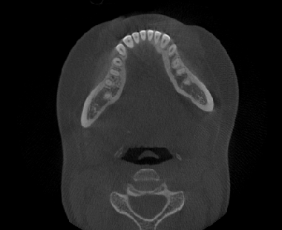 | 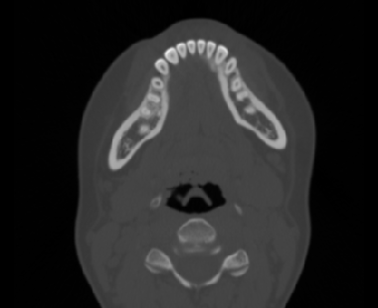 | 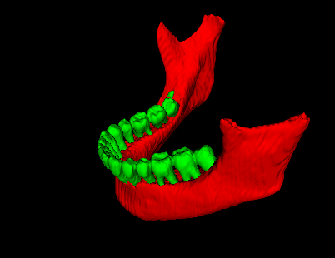
(a) CBCT axial plane | (b) CT axial plane | (c) lower teeth and mandible
Figure 1 Example of images after registration.

2.2 Network
The network architecture for generating synthetic CT images from CBCT images are shown in Figure 2. We employed a U-Net[13]based model to deal with the image-to-image translation task. The task can be defined more concretely as: given input CBCT volumetric image $I_{CBCT}∈R^{D×H×W}$, we want to generate a synthetic image $I_{sCT}∈R^{D×H×W}$. The voxel values in synthetic CT (sCT) are desired to be the same as ground-truth CT $I_{CT}$, thus a mapping from CBCT gray scale value to CT HU. After registration, we produced lower teeth and mandible region registered $I_{CBCT}$, $I_{CT}$ and corresponding region mask $M$. Then a supervised learning algorithm can be applied to guide the CT synthesis procedure.
Considering the computational limitations, the proposed network learns the mapping slice-by-slice along the z axis. In order to bring some information along z axis to help with the task, we stack one slice before and after the current slice as input data.
The network has two path called “encoder” and “decoder”. The encoder path is made of convolutional blocks and max pooling layers. Each block takes an input applies a $3×3$ convolution layer, a batch-normalization layer and a ReLU layer. Through the encoder path, feature maps are gradually down sampled by a $2×2$ max pooling layer to reduce the feature dimension. The number of convolutional kernels increased so that the network can learn more complex patterns effectively. With regard to the computational efficiency, we only double the feature map number after first three max pooling layers. The decoder path consists of several similar convolutional blocks and transposed convolution layer. The features from the encoder path are first up sampled by the transposed convolution layer, then concatenate with the feature maps in corresponding encoder layer. After concatenation, the different features are fused by some convolutional blocks. The number of convolutional blocks in decoder path is the same as the encoder path. Finally, a $1×1$ convolution layer is applied to predict $I_{sCT}$ slice.
We chose smooth L1 loss to supervise the predicting process. CBCT image exists abnormal gray scale values which can lead to problem when training the network. Smooth L1 loss are more robust to the outliers. Note that we only compute the loss in lower teeth and mandible mask region $M$. The loss function can be defined as:
$$loss\left(I_{sCT}, I_{CT}\right)=\left\{\begin{matrix}0.5∙M∙{\left|I_{sCT}- I_{CT}\right|}^{2} & if \left|I_{sCT}- I_{CT}\right|<1 \\ M∙\left|I_{sCT}- I_{CT}\right|-0.5 & otherwise.\end{matrix}\right.$$
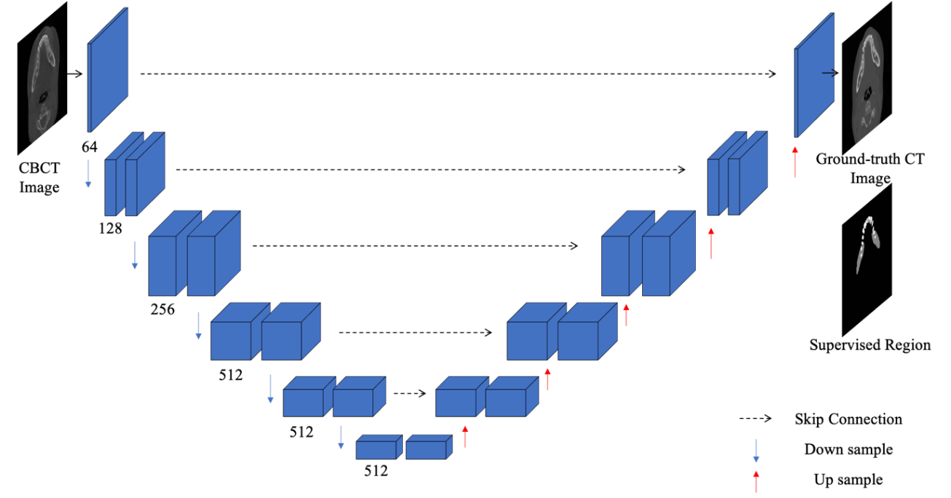
Figure 2 Network architecture.

3. Results and discussion
3.1 Network training
Of the CBCT and ground truth CT images from 63 patients used as training dataset and testing dataset, we only used slices containing the lower teeth and mandible masks. In total 5753 slices were present in the dataset. 57 patients with 5218 slices were used as training dataset. The slices were shuffled into a training and a validation set with 4663 slices in the training set and 555 in the validation set. The final training was optimized by an Adam optimizer with a learning rate of 2e-4. After inspecting the loss function on the training and validation set, we opted for utilizing 450000 iterations (~100 epochs) for the network training. The model with smallest validation loss was used to evaluate the optimal network on the testing data set with 555 slices from 6 patients not used in the training dataset.
3.2 Qualitative results
The synthetic CT images were visually compared with the ground truth CT images to evaluate the performance of the proposed network. We show the synthetic CT images together with the original CBCT images and the ground truth CT images in Figure 3-5. Less artifacts were found in the synthetic CT images than in the original CBCT images. Significantly lower or higher intensity of pixels in original CBCT than in ground truth CT in high intensity objects are visibly corrected in synthetic CT as pointed by red arrows in Figure 4 and 5. The same conclusion can be drawn from the residual image between the synthetic CT image and the ground truth image as compared to between the original CBCT image and the ground truth image. The CT numbers of the synthetic CT image are much closer to those of the ground truth CT image than those of the CBCT image.
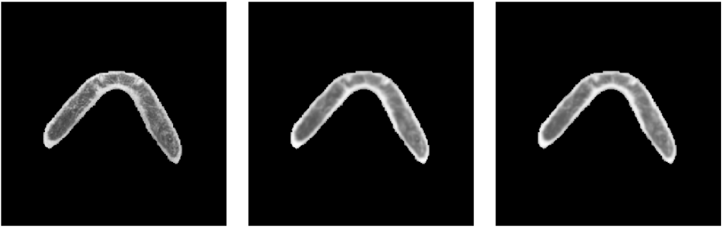
(a) | (b) |  | (c)
(d) |  | (e)
Figure 3 Testing sample one. (a) CBCT image; (b) ground truth CT image; (c) synthetic CT image; (d) residual image between CBCT image and ground truth CT image; (e) residual image between synthetic CT image and ground truth CT image.
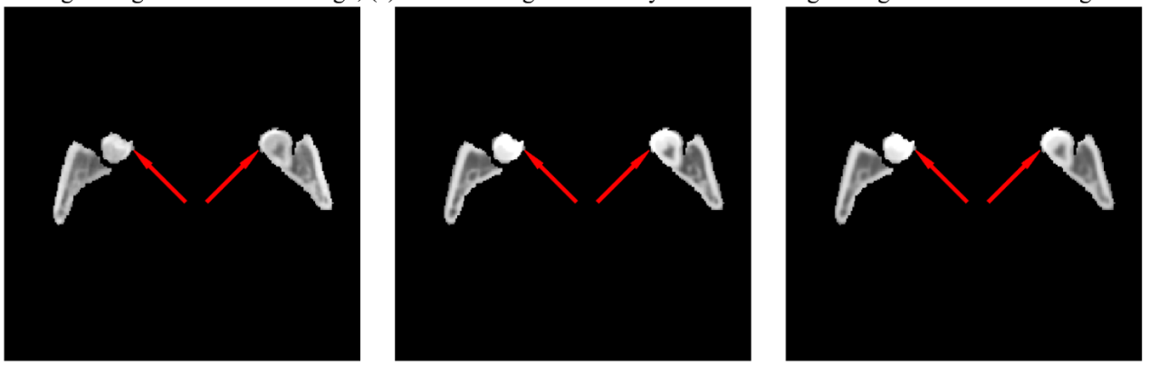
(a) | (b) |  | (c)
(d) |  | (e)
Figure 4 Testing sample two. (a) CBCT image; (b) ground truth CT image; (c) synthetic CT image; (d) residual image between CBCT image and ground truth CT image; (e) residual image between synthetic CT image and ground truth CT image.
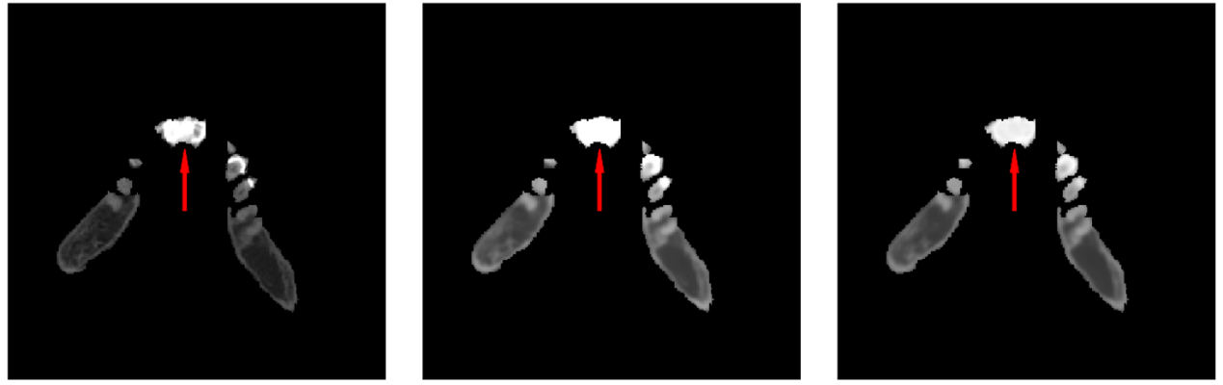
(d) |  | (e)
Figure 5 Testing sample three. (A) CBCT image; (b) ground truth CT image; (c) synthetic CT image; (d) residual image between CBCT image and ground truth CT image; (e) residual image between synthetic CT image and ground truth CT image.
3.3 Quantitative analysis
Evaluation was done with 4 similarity measures between the synthetic CT images $I_{s}$ and the ground truth CT images $I_{CT}$: mean absolute error (MAE), root-mean-square error (RMSE), structural similarity index (SSIM), and peak-signal-to-noise ratio (PSNR). Given the lower teeth and mandible mask as a set M of pixels with the total number of $|M|$ pixels in the set, the following definition are given for each of the 4 similarity measures:
MAE is the mean absolute error of all pixels in set $M$ and can be calculated as:
$$MAE\left(I_{sCT}, I_{CT}\right)=\frac{1}{|M|}\sum_{i∈M}{|I_{sCT}\left(i\right)- I_{CT}(i)|}$$
RMSE can be calculated as:
$$RMSE\left(I_{sCT}, I_{CT}\right)=\sqrt{\frac{1}{|M|}\sum_{i∈M}{{|I_{sCT}\left(i\right)- I_{CT}(i)|}^{2}}}$$
PSNR is used to evaluate image quality, especially for noise reduction, and can be calculated as:
$$PSNR\left(I_{sCT}, I_{CT}\right)=20∙\log_{10}{MAX(I_{CT})}-10∙\log_{10}\left(\frac{1}{|M|}\sum_{i∈M}{{|I_{sCT}\left(i\right)- I_{CT}(i)|}^{2}}\right)$$
Structural information is considered in SSIM to compare the quality of the predicted image with that of the ground truth image. SSIM can be calculated as:
$$SSIM\left(I_{sCT}, I_{CT}\right)=\frac{(2μ_{I_{sCT}}μ_{I_{CT}}+c_{1})(2σ_{I_{sCT}I_{CT}}+c_{2})}{(μ_{I_{sCT}}^{2}+μ_{I_{CT}}^{2}+c_{1})(σ_{I_{sCT}}^{2}+σ_{I_{CT}}^{2}+c_{2})},$$
where $μ$ is the mean value of the image inside the mask set $M$, $σ$ is the standard deviation of the image inside the mask and $σ_{I_{1}I_{2}}$ is the covariance of two images $I_{1}$ and $I_{2}$ inside the mask. $c_{1}$ and $c_{2}$ are two variables that stabilize the division with a weak denominator. We set $c_{1}$ to $(0.01{L)}^{2}$ and $c_{2}$ to $(0.03{L)}^{2}$, where $L$ is the dynamic range of the pixel values in the ground truth CT image inside the mask set $M$.
The similarity measures over the test patients are reported in Table 1. Significant improvement in MAE, RMSE and PSNR are observed. Since the SSIM measurement is already high in original CBCT, even though the resulting SSIM value is over 0.97, the improvement percentage is relatively low.
The MAE numbers are relatively higher as compared to the results in [14] or [15]. This is due in part to the fact that dental scanning has a larger dynamic range in the CT image and the pixels in the lower teeth and mandible mask has higher intensity as compared to a chest or H&N CT scan. The baseline MAE of CBCT is much higher than those in such applications. Another reason MAE results are higher is that the deformed reference CT may not be perfect aligned with the CBCT image, and because the total number of pixels in the mask is small (~1.7% of all pixels in the testing dataset), a small offset in alignment may result in a higher portion of the pixels mismatched. This is compounded by the high pixel intensity issue and thus making the MAE measurement larger.
Table 1 Similarity measures and improvement percentages over testing dataset
 | SSIM | PSNR | MAE(HU) | RMSE(HU)
CBCT | 0.8516 | 19.47 | 248.41 | 432.50
Synthetic CT | 0.9717 | 28.96 | 88.34 | 145.16
Improvement % | 14.10% | 48.47% | 64.44% | 66.44%

Quantile-Quantile (Q-Q) plots between ground truth CT and CBCT, and between ground truth CT and synthetic CT are displayed in Figure 6. The closer the blue dots are to the red line $y=x$, the better agreement between the distributions is expected. Large shift is observed between points in the Q-Q plot of CBCT with ground truth CT and $y=x$ while in the Q-Q plot of synthetic CT the points almost perfectly lie on $y=x$, regardless of ground truth CT HU, indicating that the synthetic CT has nearly the same distribution as the ground truth CT.
(a) | (b)
Figure 6 Quantile-quantile plots of (a) CBCT and (b) synthetic CT with ground truth CT.
To better demonstrate the improvement on different anatomical structures, we divide the ground truth CT pixel intensity range (-1000HU~3500HU) to 20 HU intervals and for pixels in each interval in the ground truth CT images, MAE measurement is computed for both CBCT and synthetic CT images. A plot of the MAE measurement for each interval is shown in Figure 7. The HU ranges of different tissues. From the plot, the MAE level for most of the tissues are small enough to separate different tissues, except for bone cyst and root canal/cystic tumor of which the HU ranges are too close and are difficult to separate even in CT images. Table 2 shows the Hounsfield unit ranges of different tissues, together with MAE for both CBCT and synthetic CT in each of the tissue HU ranges. It shows significant reduction in MAE measurement for all tissues. The reduction is especially important for tissue/material with higher intensity like cortical bone and implant since this makes it possible to separate such tissue/material from tissues with similar HU level.
Figure 7 Plot of MAE measurement for different HU interval in ground truth image. The plot is overlaid with HU ranges of different tissues.

Table 2 Hounsfield unit ranges of different tissues and MAE measurement of different tissue ranges for CBCT and synthetic CT
Tissue | Hounsfield unit range | CBCT MAE (HU) | Synthetic CT MAE (HU)
Bone cyst ǂ | 0 | 144.81 | 52.82
Root canal / cystic tumor | 20-40 | 149.16 | 46.28
Cancellous bone ǂ | 542 | 219.30 | 86.38
Dentin | 1000-1500 | 239.79 | 88.74
Cortical bone ǂ | 1766 | 398.20 | 158.22
Implant | 2500-15000 | 1596.64 | 191.47
ǂ MAE is computed within [-10HU, 10HU] range centered on the Hounsfield unit value.

3.4 Discussion
Synthetic CT proves more powerful in differentiating tissues than CBCT does. According to Hounsfield units’ range of various tissues, the minimum discrepancy between that of dentin and that of cancellous bone is 458 HU. The sum of CBCT MAE value of those tissues is 459.09 HU, just exceeding 458 HU, so that CBCT is unable to distinguish them. In comparison, the sum of synthetic CT MAE value of these tissues is 175.12 HU, less than 458 HU, rendering synthetic CT effective distinguish them. For the same reason, dentin and root canal can be differentiated by both CBCT and Synthetic CT. Implants and cortical bone can be discriminated by only synthetic CT, but not CBCT. Neither synthetic CT nor CBCT can differentiate bone cyst and cystic tumor, due to intrinsic limited resolution of soft tissue by CBCT. Post processing of the CBCT data proved ineffective.

4. Conclusion
Our experimental results of the four indicators show that compared with the original CBCT data, the synthetic CT has a significant improvement. CBCT and synthetic CT values can be used to distinguish different high-attenuation structures that are of interest to dentists, including dentin and cancellous bone, dentin and root canal，implants and cortical bone. The application of CBCT assisted by this U-net based network in medical imaging of other parts of the body is promising. Furthermore, there is a bright future of medical imaging integrated with this network, leading to more precisive anatomy.

List of abbreviations
CBCT: cone-beam computed tomography
CT: computed tomography
COVID-19: corona virus disease 2019
AI: artificial intelligence
HU: Hounsfield units
FOV: field of view
ReLU: rectified linear unit
MAE: mean absolute error
RMSE: root-mean-square error
SSIM: structural similarity index
PSNR: peak-signal-to-noise ratio
Q-Q plot: quantile-quantile plots

Declarations
Ethics approval and consent to participate
This research was approved by the Shanghai Ninth Hospital Research Ethics Committee. Written informed consent was obtained for each participant.

Consent for publication
Not applicable

Availability of data and materials
The datasets generated and analysed during the current study are not publicly available due to patients’ individual privacy but are available from the corresponding author on reasonable request.

Competing interests
The authors declare that they have no competing interests.

Funding
This study has received funding by the Interdisciplinary research of 9th People's Hospital affiliated to Shanghai Jiao Tong university School of Medicine (Grant Number JYJC201803).

Authors' contributions
WJ collected patients’ imaging data and was a major contributor in writing the manuscript
TX provided experienced clinical advices
ZL analyzed and interpreted the patient data
YJ analyzed and interpreted the patient data
LC analyzed and interpreted the patient data
XS analyzed and interpreted the patient data and was a major contributor in writing the manuscript
DX provided technical advices and was a major contributor in writing the manuscript
ZL designed the research and was a major contributor in writing the manuscript
All authors read and approved the final manuscript.

Acknowledgements
Not applicable

References
1. Nasseh, I. and W. Al-Rawi, Cone Beam Computed Tomography. Dent Clin North Am, 2018. 62(3): p. 361-391.
2. Kamburoglu, K., Use of dentomaxillofacial cone beam computed tomography in dentistry. World J Radiol, 2015. 7(6): p. 128-30.
3. Haas, L.F., et al., Precision of cone beam CT to assess periodontal bone defects: a systematic review and meta-analysis. Dentomaxillofac Radiol, 2018. 47(2): p. 20170084.
4. Meng, L., F. Hua, and Z. Bian, Coronavirus Disease 2019 (COVID-19): Emerging and Future Challenges for Dental and Oral Medicine. J Dent Res, 2020: p. 22034520914246.
5. Emadi, N., et al., Comparison of CT-Number and Gray Scale Value of Different Dental Materials and Hard Tissues in CT and CBCT. Iran Endod J, 2014. 9(4): p. 283-6.
6. Reeves, T.E., P. Mah, and W.D. McDavid, Deriving Hounsfield units using grey levels in cone beam CT: a clinical application. Dentomaxillofac Radiol, 2012. 41(6): p. 500-8.
7. Thing, R.S., et al., Hounsfield unit recovery in clinical cone beam CT images of the thorax acquired for image guided radiation therapy. Phys Med Biol, 2016. 61(15): p. 5781-802.
8. Pauwels, R., et al., CBCT-based bone quality assessment: are Hounsfield units applicable? Dentomaxillofac Radiol, 2015. 44(1): p. 20140238.
9. Molteni, R., Prospects and challenges of rendering tissue density in Hounsfield units for cone beam computed tomography. Oral Surg Oral Med Oral Pathol Oral Radiol, 2013. 116(1): p. 105-19.
10. Schroder, L., U. Stankovic, and J.J. Sonke, Technical Note: Long-term stability of Hounsfield unit calibration for cone beam computed tomography. Med Phys, 2020.
11. Patrick, S., et al., Comparison of gray values of cone-beam computed tomography with hounsfield units of multislice computed tomography: An in vitro study. Indian J Dent Res, 2017. 28(1): p. 66-70.
12. Komori, M., et al., The gray scale value of ear tissues undergoing volume-rendering high-resolution cone-beam computed tomography. Auris Nasus Larynx, 2018. 45(5): p. 971-979.
13. Ronneberger, O., P. Fischer, and T. Brox, U-Net: Convolutional Networks for Biomedical Image Segmentation. International Conference on Medical image computing and computer-assisted intervention, 2015.
14. Chen, L., et al., Synthetic CT generation from CBCT images via deep learning. Med Phys, 2020. 47(3): p. 1115-1125.
15. Liang, X., et al., Generating synthesized computed tomography (CT) from cone-beam computed tomography (CBCT) using CycleGAN for adaptive radiation therapy. Phys Med Biol, 2019. 64(12): p. 125002.

